-- retrive the total numbers of orders placed.

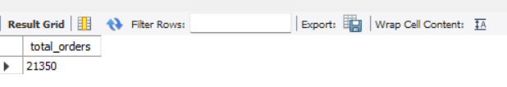

-- calculate the total revenue generated from pizza sales.

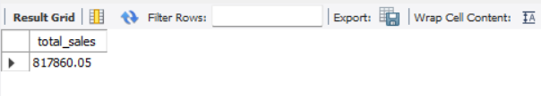

-- Identify the highest-priced pizza.

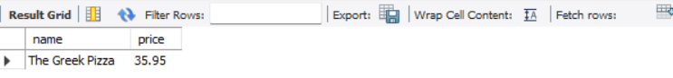

-- identify most common pizza size ordered

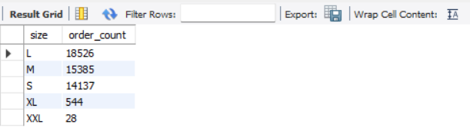

-- list the top 5 most ordered pizza types along with their quantity

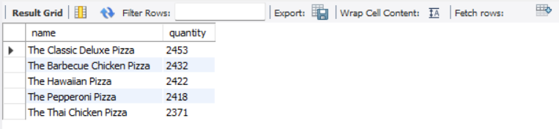

--Identify revenue by pizza category

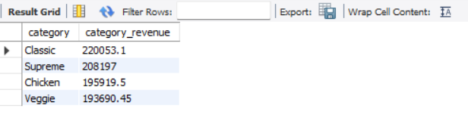

-- Identify Monthly revenue

